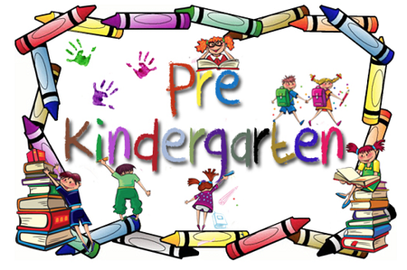
Wish List
- Wipes
- Ziplock bags (large and small)
- Hand sanitizer
- A change of clothing labeled with child’s name
- Small blanket
- Kleenex
- Snacks

