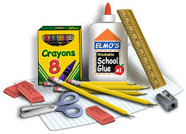
School Supply List
Lee Street Elementary
3rd grade Team
For more information or questions, Contact: Shana.alexander@clayton.k12.ga.us

- (1) 1” Binder
- (2) packs Wide ruled notebook paper
- (4 packs) #2 sharpened pencils with erasers (no mechanical)
- (1) pack of glue sticks
- 12 inch ruler with centimeters
- (4) Composition notebooks (no spiral)
- (1) pack Crayon
- (2) red ink pen
- (2) Dry erase markers
- (1) bottle of hand sanitizer
- (1) Kleenex
- (1) pack Large pink erasers
- (2) Highlighters
- Book bag (no rolling book bags)
- (2) pairs of scissors

